**گرمخانه-آون**-**OVEN**

**EN1097-6-ASTMC127.F1360.C136.D558.D698.D1557.D1559**

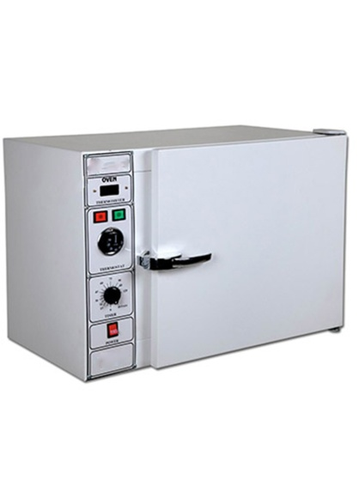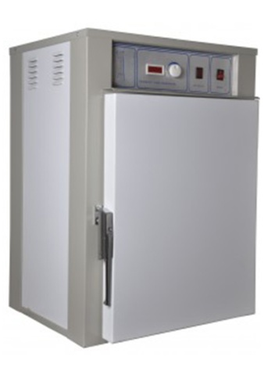 200

AG101

AG102

AG104